**HANA EIM Demonstration FlowGraphs.**

The demonstrations below are packaged up in a Delivery Unit so you can import them onto your own HANA environment for example, Monsson or SAP HANA Express (you will need to enable the DPServer).

As well as the actual FlowGraphs in the Delivery Unit there are also 2 files that contain SQL to create the source tables including sample data. All the targets are template tables which will be created when you execute the FlowGraphs.

You can download the Delivery Unit here - [HANA_EIM_TRANS-EIM.tgz](https://jam4.sapjam.com/profile/3Dyi61kPl0gYsaXJCzTLKV/documents/DHIw98nRmVDr1d31AsZ387) You may get an error when importing saying "Schema object does not exists: "EIM_DEMO". This is because we haven't created the schema yet. This is in the SQL file.

**Case Transform**

This transform is used to route records based on a value. In this demo customer records are routed to different target tables based on the region value.

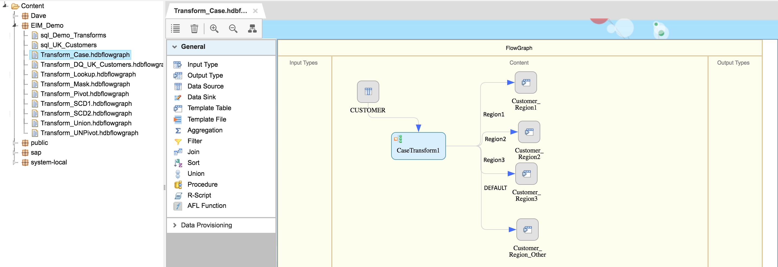

**Cleanse and Match**

These transforms are used to parse, standardise, correct & enrich person, firm, address information as well as identify potential duplicate records. This demo extracts input records based on UK addresses, cleanses the names / addresses and then uses the match transform to identify duplicates based on rules.

**Note:** For address cleansing you will need to download the UK Address Directory from SWDC and move it to /usr/sap/<SID>/SYS/global/hdb/IM/reference_data

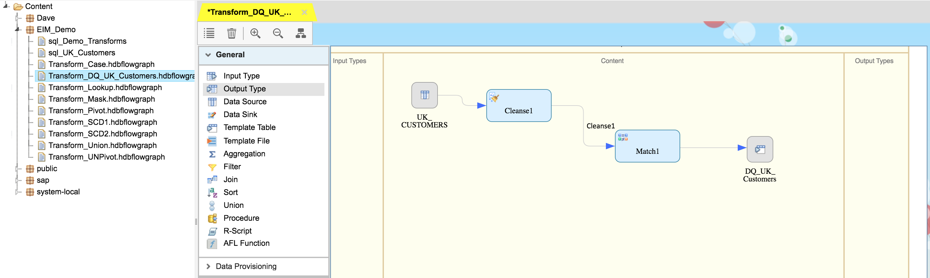

**Lookup**

This transform retrieves column value(s) from a lookup table that matches an expression. This demo lookups the Region Name from the Region tables and adds it to the output from the Customer table.

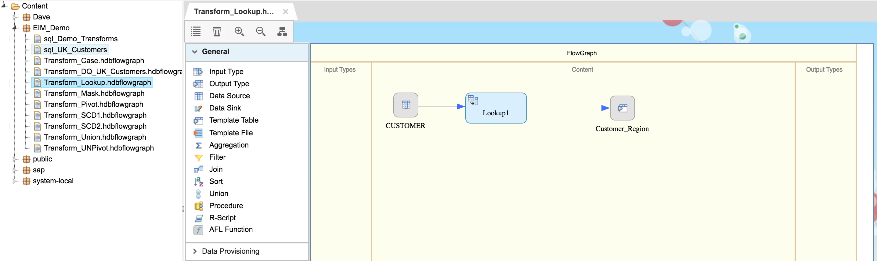

**Datamask**

This transform Protects the personally identifiable or sensitive information by covering all or a portion of the data. This demo takes employee data and masks the start date using a variance, bank account using pattern variance and salary using mask.

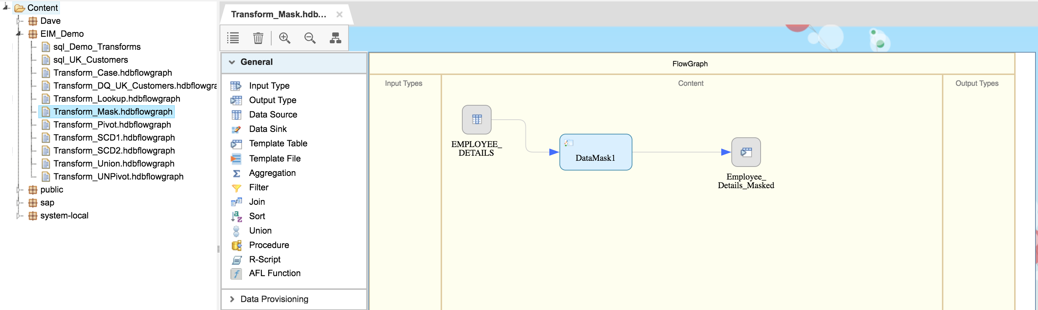

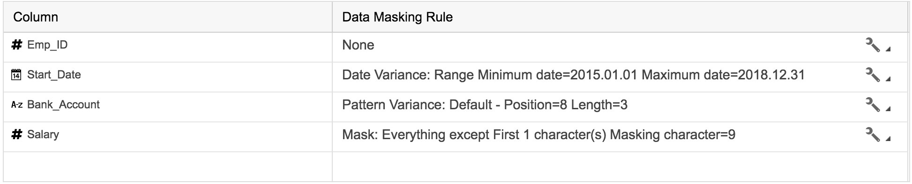

**Pivot**

This transform turns rows into columns. This demo takes the property and property value fields and outputs the values of the property field into separate columns for property each value.

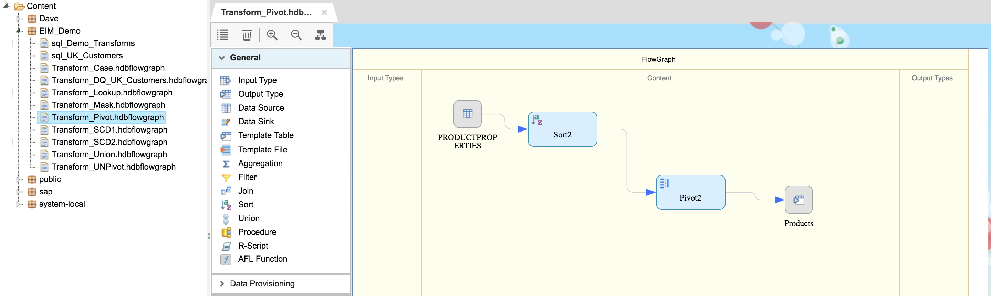

**Unpivot**

This transform turns columns into rows. In this demo the input table has separate columns for each sales and cost quarter. The output of the unpivot transform produces a single column for sales values and a single column for cost values which enables easier aggregation of the values.

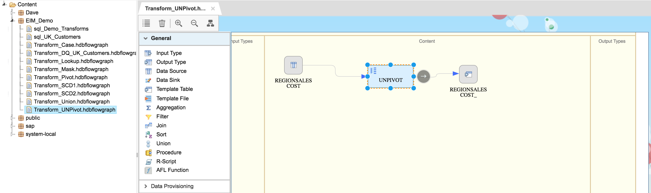

**Table Comparison - SCD1**

This transform compares 2 tables and produces the difference between them flagged as insert, update, delete. This demo compares the name and address values of the data source with the target table.

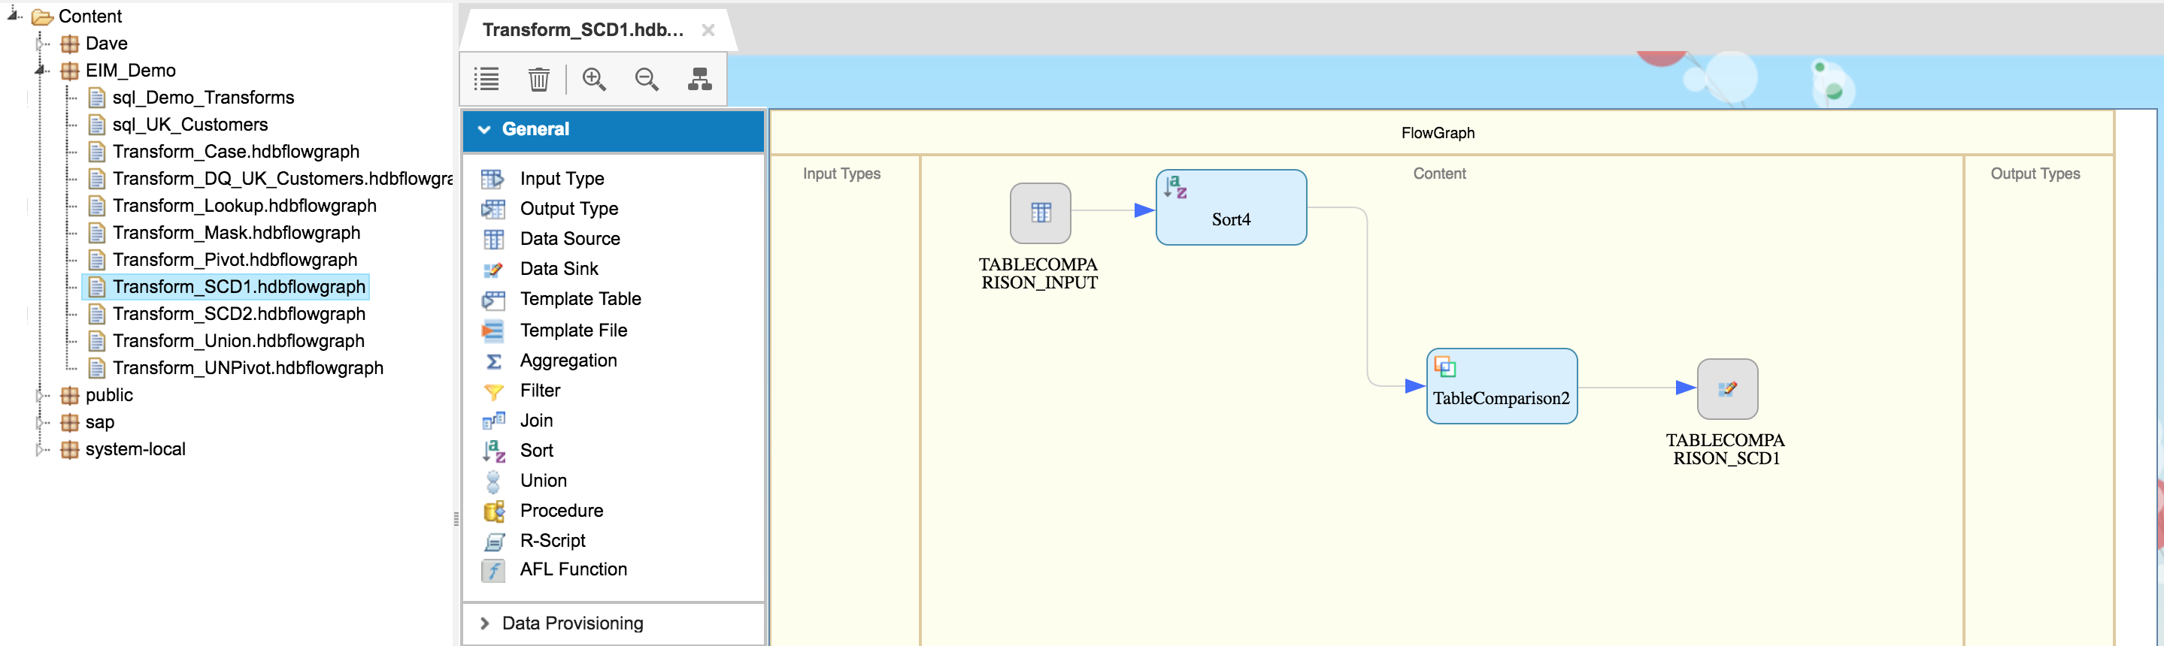

**Table Comparison - SCD2**

The history preserving transform allows you to produce a new row in the target table rather than update an existing row. This demo uses the table comparison transform to produce the difference between the source and target. The history preserving transform then adds / updates some additional columns depending on if a new record has been added or if it’s an updated record. The additional fields include a valid from and valid to date as well as a flag to determine if it’s the latest record.

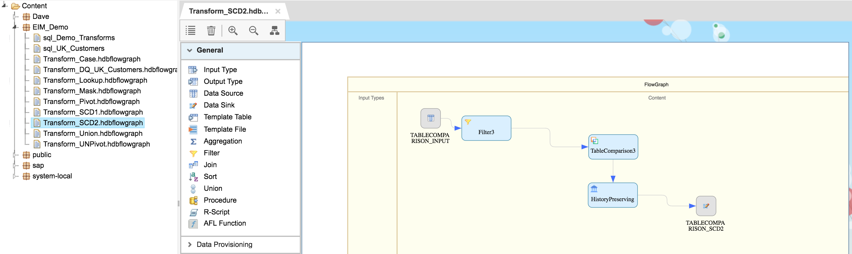

**Union**

This transform produce a result set from 2 tables with the same schema. This demo uses the Employee and Customer tables as a source. To use the union transform the output of both sources must match. The employee table has Name split across 2 fields whereas Customer is in one field. Using the Employee filter transform the name columns are concatenated together to match the Customer format.

